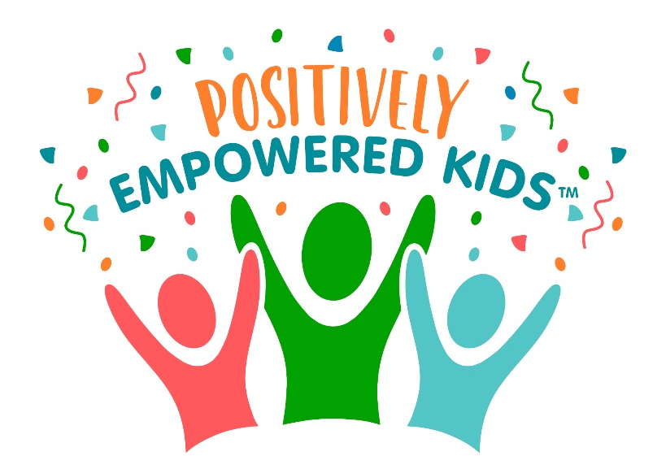

Positively Empowered Kids (PEK) CIC is an awarding winning social enterprise, based in Nottingham. The primary objective of PEK is to educate, empower and inspire the next generation to raise their consciousness, grow healthy thriving minds and unlock their potential.

Collaboration and support are at the heart of PEK; connecting families and schools together via a strong network of wellbeing experts for a better outcome for every child. Using an early intervention and prevention model gives children the ability to handle whatever is facing them in their life. Our team are continuously innovating; moving events online and providing a free to access portal entitled our ‘family empowerment hub’ over the last year.

A thriving community around a child/young person is crucial to support the life chances of the child; this age-old mantra of ‘it takes a village to raise a child’ is still true today. By launching our first online community group; ‘Positively Empowered Communities in Gedling Borough’ ensures access to activities and events to boost the wellbeing of the community, creating a blueprint for further community projects has been developed.
We also believe the wisdom of young people must be listened to and acted upon. We have recently launched our Youth Voice in Action Project, In partnership with Vocaleyes digital democracy platform, we have kickstarted a “Big Conversation” for Youth Voice, taking it further into support young people to take action.

Founders Jackie Wilson & Claire Clements can be reached via email pekcic@gmail.com
Website www.positivelyempoweredkids.co.uk
You Tube https://www.youtube.com/channel/UC6yhhZHkEwgUWBYARDAANiw
Facebook page https://www.facebook.com/PEKFamilies
Facebook Community Group https://www.facebook.com/groups/positivelyempoweredcommunities

